“The machine-olfaction competition”
Regulation
1. Introduction
We are pleased to announce the 5th edition of the Sniffest. Since its creation, Sniffest aims to attract new talent to the sensor community, create advance perspectives in the field by promoting practical and original solutions using sensors-associated valuable skills.
In the 5th edition, which will take place during the ISOEN conference, to be held in Chongqing, China, from May 17–20, the students will have the opportunity to show their capacities, bringing their own developed equipment to the test in ISOEN 2026.

2. Eligibility
To be eligible to participate in the event, the students must be enrolled in an undergraduate or graduated degree (including PhD) program at an accredited university and must be sponsored by a senior researcher (e.g., faculty mentor, industry
collaborator). Students interested in participating must submit an application file to email (isoen2026@youngac.cn) by deadline, February 1, 2026. Two is the minimum for each team, allowing up to 4 team members (maximum), and a maximum of 2 teams per laboratory are allowed. The application must include the following information:
- Team name;
- Affiliation (name of the school);
- Team roster (name of the students);
- Sponsor (name and contact information), and
- A brief narrative (500 words) of the team’s qualifications, motivation to compete, and proposed solution.
The sponsor will be asked to provide a letter of recommendation. The letter should state the capabilities of the team, resources (e.g., equipment, facilities) that will be made available to the team, and commitment to cover travel and lodging expenses for at least one member of the team.
A team of technical experts will review. Selections will be based on the team’s
qualifications, originality and feasibility of the solution, and the endorsement from the
sponsor. Invitation letters will be announced by February 28.

3. The Event
The 5th edition of Sniffest will focus on the recognition of Chinese Medicinal Herbs (CMHs) which features one of the Chinese traditional civilization.
(1) Qualifying Round: Identification of Single Medicinal Herbs
We will provide the participating teams with a list of 8 CMHs involved in this competition (details below). During the competition, each herb will be presented as powder to ensure uniformity and comparability of odor. At the competition site, the organizing committee will randomly select 3 herbs from the list as test samples. Teams must use their own electronic nose devices to identify these 3 herbs based on their odor characteristics. Identification results are determined solely by the display of electronic nose device (The e-nose should be programmed ahead of time), manual judgment or human intervention is strictly prohibited. Teams that accurately identify all 3 herbs within the allotted time will qualify for the final round. Each team will receive samples of 5 herbs out of the 8 CHMs during the conference for calibrating/training their electronic nose devices.
The 8 CMHs provided at the competition site are as follows:
 | Name | picture | Odor Characteristics | Odor Intensity
1 | Radix Bupleuri | 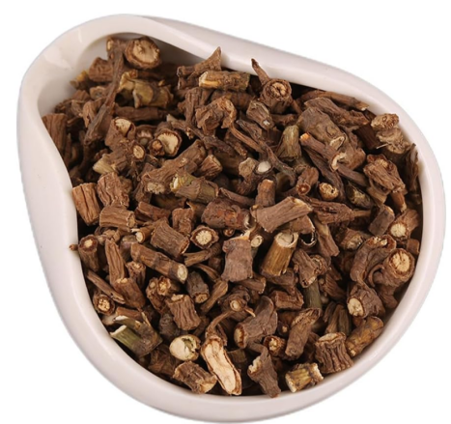 | Grassy, slightly bitter aroma | Medium
2 | Angelica Sinensis | 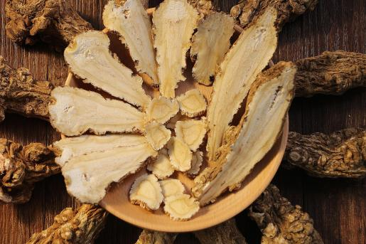 | Pungent,  sweet aroma | Strong
3 | Rhizoma Atractylodis Macrocephalae | 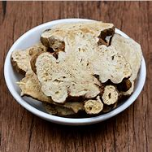 | Pungent aroma, earthy bitter scent | Strong
4 | Liquorice | 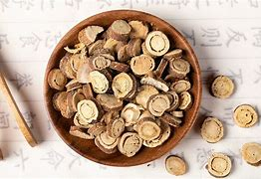 | Sweet aroma | Medium
5 | Fresh Ginger | 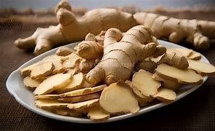 | Spicy, pungent aroma, stimulating | Strong
6 | Rhizome Chuanxiong | 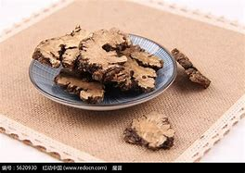 | Intensely pungent, slightly cool, similar to Angelica Sinensis | Strong
7 | Cinnamon | 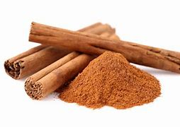 | Intensely aromatic, spicy-sweet, distinct warm fragrance | Strong
8 | Prepared Rehmannia Root | 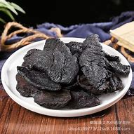 | Mildly sweet aroma, reminiscent of caramel or syrup, slightly fermented scent | Medium
（2）Final Round: Identification of Binary Mixed CMHs
At the competition site, the organizing committee will randomly select 2 herbs from a list of 5 CMHs (which are out of the 8 CMHs above, and will be announced 3 months in advance) to create a binary mixture (The weight ratio of the two herbs is 1:1). Two such mixture groups will be prepared. The participating teams must use their electronic nose to identify which two herbs make up each of the mixed samples. Identification results are determined solely by the electronic nose display, manual judgment or human intervention is strictly prohibited. The primary criterion for scoring is detection accuracy. If teams have the same accuracy rate, the winner will be determined by the one with shorter total detection time.
The competition will set 1 first prize, 2 second prizes, several participation prizes, and additionally 1 best innovation award.

4. Financial support
ISOEN does not have the financial resources to cover the travel and accommodation expenses of the competition participants. However, we will offer a free registration for one student from each team, and provide a 50% discount on the student registration fee for up to two additional team members who wish to participate.

5. Questions and Answers
（1）What happens if I am not selected or miss the deadline?
You can still participate in the competition. However, only selected teams are eligible for the fee discount. If you decide to participate, please notify us one month before the conference so we can assign space for your team (subject to availability).
（2）Can I bring my own sensors or sensor boards?
The conference Organizing Committee does not provide sensors or e-nose devices; these must be supplied by the participants themselves.
（3）What type of computing platform can I use?
You are free to use any computing platform, including embedded computers (e.g., Arduino, Raspberry Pi), mobile devices (e.g., smartphones, tablets), or laptops.

